The American Legion
SONs
Squadron 240
Golf Tournament
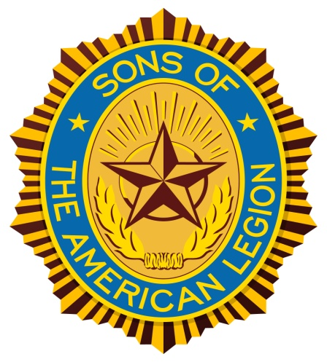
(Fundraiser–for Pensacola Special OLYMPICS)

When – 12 August, 2018, (Sunday, Shot-gun start- 0800 hrs)
Where – OSCEOLA Golf Course (300 Tonawanda Dr, Pensacola, FL 32506 )
Play -- 4 Person Scramble
Cost -- $50.00/player (Discounts for early sign-ups)
Includes :
- 18 holes of golf w/cart
- Door prizes, 1st, 2nd, and 3rd Place winners, Closest to Hole (M/F), Long Drive (M/F)
- Awards & Heavy Lunch (1 - 4 pm) - at Post 240 (8666 Gulf Beach Hwy, Pensacola)
*** Looking for support for Hole Sponsors ( Individuals/Organizations/& Business Sponsors)
A.L. SONs Squadron 240 Golf REGISTRATION FORM
Entry-- DEADLINE –-- 5 August, 2018
Player Phone/e-mail Approx. HDC
1__________________________________________________________
2__________________________________________________________
3__________________________________________________________
4__________________________________________________________
*** Please submit a reasonable team with A, B, C, & D handicaps.

Early Registration for 4 person teams
- 4 Person Teams Post marked by 5 Aug ------------------ $180.00 / team
- 4 Person Teams Post marked/ called in after 5 Aug - $200.00 / team
Hole Sponsors (All hole sponsors will be recognized at the golf course & post)
- Individuals ***------------------------------------------------- $20.00
- Organizations – i.e. Post, Auxiliary, Riders or SAL --- $25.00
- Business -------------------------------------------------------- $50 +

Make Checks payable to “American Legion, SONs”, and mail to : John Edens, Tournament Director, 5471 Keel Dr., Pensacola, FL 32507. I can be reached at : H-850-492-7082 or C-229-444-3534 or E-mail: commander@americanlegion240.org. Entry notification will be sent back to you by E-MAIL or PHONE by 7 Aug, 2018…..

